**Figure 1 Legend**



**Figure 3 Legend**



**Figure 4a Tukey AGP (Top Left) Legend**



**Figure 4b Tukey AGP (Top Left) Legend**



**Figure 4c Tukey AGP (Top Left) Legend**



**Figure 4c Dexcom Clarity (Bottom) Legend**

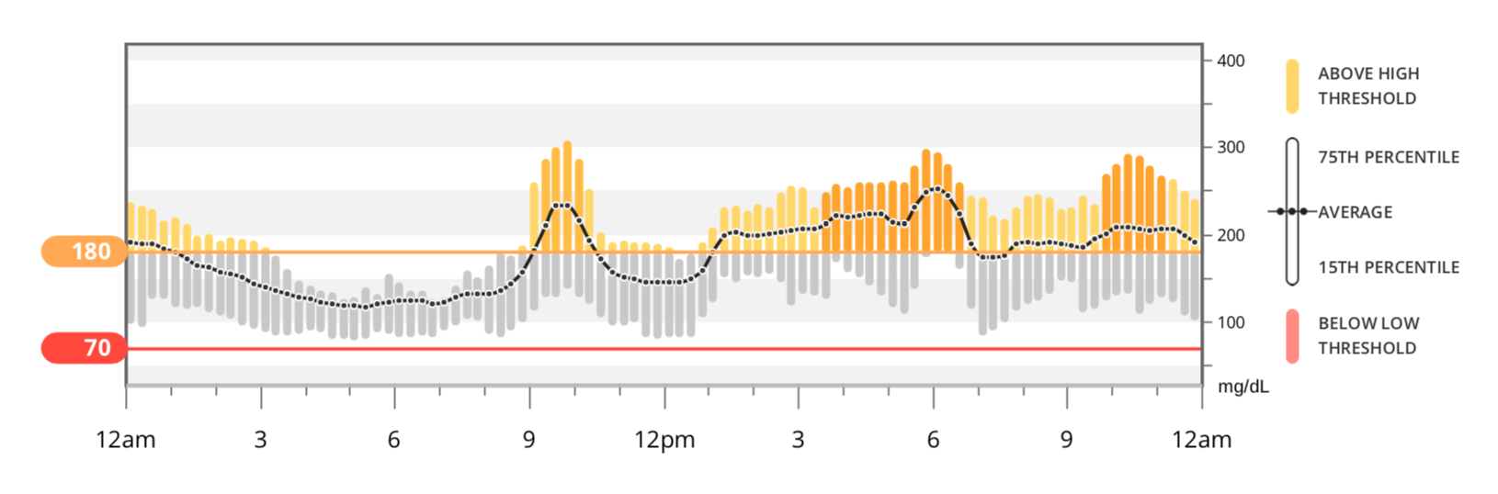

**Figure 4d Tukey AGP (Top Left) Legend**



**Figure 4d Tukey AGP (Bottom) Legend**

